Demonstrate how to work collaboratively in Git/GitHub on a project using the fork-and-push request workflow.

Create new folder and save code there and open terminal in that

1.git init

2.git add .

3.git commit -m “initial commit”

copy the link from the new repository in github

4.git push origin master

Create a GitHub Repository and Implement Version Control Tasks: • Set up a repository for a team project. • Create branches for individual modules. • Merge branches with pull requests after code reviews.

Do the above steps and then

1.git branch

2.git branch employee

3.git branch

4.git checkout employee

5.git branch

After that gob to old file and do some changes and open terminal

6. git add .

7. git commit -m "commit changes"

8. git push origin test

9. git push origin employee

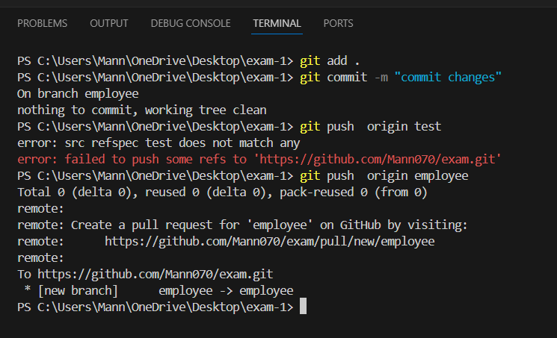

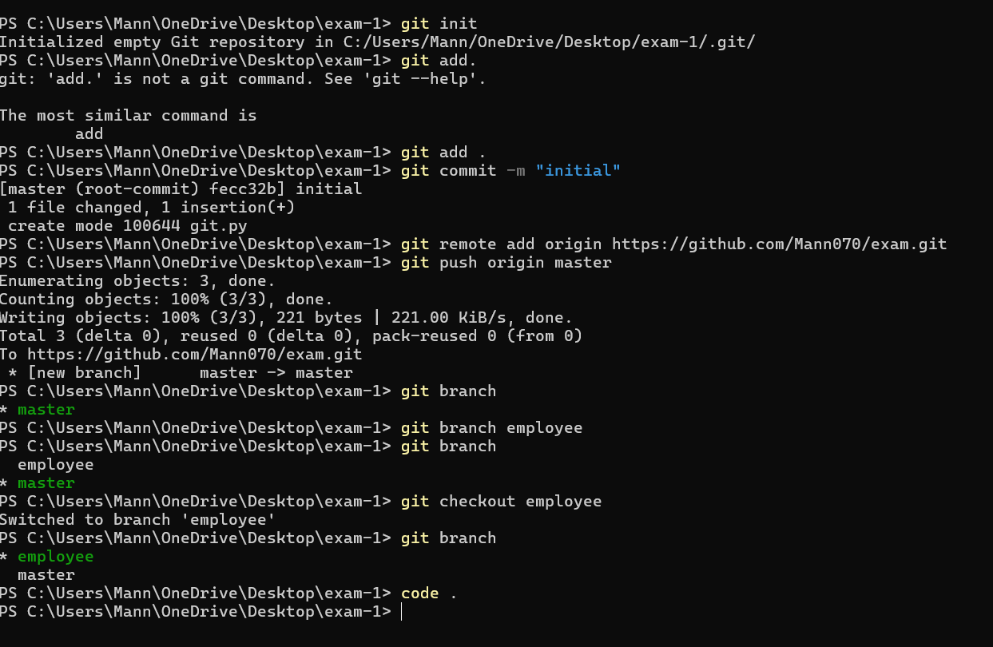

Activity 9

git config --global user.name "Harsha Kyle"

git config --global user.email "harshakyle1@gmail.com"

git clone https://github.com/Harsha-Kyle/SE.git

cd se

git checkout -b add-new-feature

(Add a new file locally)

git add .

git commit -m "Add multiply_numbers function and update README"

git push origin add-new-feature

(now accept pull request on GitHub)

Activity 10

git clone https://github.com/Harsha-Kyle/SE.git

cd se

git checkout -b add-new-feature

(Add a new file locally)

git add .

git commit -m "Add multiply_numbers function and update README"

git push origin add-new-feature

git checkout main

git pull origin main

(now accept pull request on GitHub)

docker build -t python3115-trial .

docker run -t python3115-trial

docker tag python3115-trial cvk22

docker push cvk22/python3115

docker ps

docker ps -a

